Shabbos Stories for
Parshas Ki seitzei 5781
Volume 13, Issue 52 13Elul/August 21, 2021
Printed L’illuy nishmas Nechama bas R’ Noach, a”h

For a free subscription, please forward your request to keren18@juno.com
Past stories can be found on the website ShabbosStories.com

The Ahavas Yisroel of
The Pnei Menachem

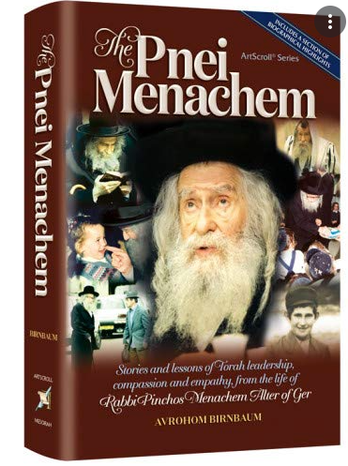

A truly great leader is one whose heart pulsates with feeling for others. The Gerrer Rebbe, zl, the Pnei Menachem (Rabbi Pinchos Menachem Alter), was such a leader. His heart flowed with love and compassion for every Jew – chasid or not. He comforted the broken-hearted even before they had the state of mind to articulate their emotions. He read between the lines of their letters, and he heard what they did not have the fortitude to express.
At times, his thoughtfulness was expressed with a minor act of a few well-placed words. Once, a family came to the Rebbe to petition a brachah, blessing, for a member who was scheduled to undergo a difficult and complex surgery. The Rebbe gave his blessing, and he immediately rose from his chair, walked to the closet and returned with an expensive bottle of wine, “This will be opened at his seudas hodaah, feast of thanksgiving, over his full recovery. This small gesture was indicative of the Rebbe’s thoughtfulness. The family left filled with hope that things would work out.

A Yerushalayim Jew Has a Problem
A Jew in Yerushalayim had a problem. He had no connections, no protektzia, to get his special needs son into a yeshivah. As he went from one yeshivah to another, each one gave him the run around, simply because he was not “connected.” (Sadly, this occurs more often than we care to acknowledge – and not only in the Holy Land!) It appeared that no one cared; no one was willing to give up their precious time to listen and attempt to help a Jew in need.
Meanwhile, the boy was remanded to staying at home and not receiving a proper education. Finally, someone said, “Why not go to the Pnei Menachem? He helps everyone. He has a big heart. You have nothing to lose.”
The Yid had tried it all. He might as well try one more person. How shocked he was when he saw how the Rebbe took notes and gathered information. He seemed really to care. This alone made a world of difference to the man. The Rebbe said, “Return in a few days. Hopefully, I will have a positive answer for you.”

The Problem Has Been Taken Care of
A few days passed, and the man returned to the Rebbe who informed him: “It has all been taken care of. Call this number and inform them who you are. Your son has been accepted in the yeshivah.”
Surprisingly, sharing in someone’s pain is easier than sharing and participating in their joyous occasions. Taking an interest, feeling someone’s pain, often assuages one’s personal guilt. Partaking in someone’s joy is more demanding for some. “I just do not have the time or interest” is an often used excuse.
The Pnei Menachem would often exhort others to find it within themselves truly to rejoice in the joy and celebrations of others. He based this on the words of the Chidushei HaRim, his great-grandfather and founder of Gerrer Chassidus, who wrote on the invitation to his grandson’s (Sefas Emes) wedding invitation: “The minhag, custom, in Klal Yisrael is to rejoice in the simchah, joy, of others in order to plant love and friendship in the hearts of one another, thereby accustoming oneself to truly rejoice in another’s good fortune. This is the kiyum, fulfilment, of the mitzvah of V’ahavta l’reiacha kamocha, Love your fellow as yourself.”

The Rebbe Gave Quality Time to a Simcha
Indeed, when the Rebbe heard of a simchah, the throbbing of joy in his heart was visibly palpable. The Pnei Menachem felt a consummate bond with all Jews. Everyone was family. A Rebbe to tens of thousands of chassidim values every minute of his time. Thus, when he attended a simchah, he did not remain long. His was quality time, making sure that those whose celebration it was would see that he felt a kinship with them, a partnership in their joyous occasion. In the brief time that he spent there, he made sure to leave an indelible impression on the baalei simchah.
Due to his heavy schedule filled with tremendous responsibilities, the Pnei Menachem would often not be invited to simchos. Those close to him did not want to impose on him to attend. He surprised them with his presence anyway, claiming that a good friend does not wait for an invitation.
He would often share a powerful insight regarding the passage in the Talmud about Kamtza and Bar Kamtza. Apparently, a man who was friends with Kamtza and enemies with Bar Kamtza made a feast. He sent his servant to invite Kamtza, his friend, to the dinner. The servant erred, and, instead, invited Bar Kamtza, who came and was promptly ejected by the host.

Friends Never Require an Invitation
This led to a bitter revenge on the rabbinic personalities who witnessed the disgrace of Bar Kamtza and ignored it. The Pnei Menachem added that Kamtza was at fault. As a good friend of the host, he should not have waited for an invitation, but he should immediately have gone on his own – a move that would have prevented the entire debacle. Friends neither wait nor require an invitation. It is their simchah as well.

Reprinted from the Parshas Pinchas 5781 email of Rabbi A.L. Scheinbaum’s Peninim on the Torah.

Two Tales of Lost Car Keys

‘Pours His Prayer Before Hashem’
I am a teacher in a school for special children. Every morning, I have a break when I sit alone and contemplate. Behind the school there is a hill with a solitary rock designated for me where I sit and speak with Hashem.
One day, while I was sitting and praying to Father in Heaven, my key ring fell out of my hand and went under the rock that I was sitting on. I thought to myself that first I would finish speaking with Hashem and then I would get the keyring.
But what we do not do right away we forget about; I went back in without the keys. Right after shiur I went back to the rock, but the keys were gone. I checked the area, but they were not there. I went back and forth to class twice, I sat and said: “Ribono shel olam, on this keyring is my only car key. I request of You to let me find the keys. I did my part and searched, and I still have not found them, and if You decide that I should not find them, I accept it with love.”
I felt a true feeling of bitachon in Hashem, that I would accept with love whatever Hashem decided. All this was a minute-and-a-half. Just then an Arab came to me and asked what I was looking for? I told him, my car key. He said, “Come with me.” He took me to a construction site and shouted for someone to bring the keys, they were mine, which I thought I would never see again. .

On Chol HaMoed we went out with the family to pick flowers. There were other families there picking flowers l’kavod Yom Tov. I saw our friends walking back and forth between the rows of flowers looking for something. They said, they lost the car key, and they had no way to start the car and what if this was their only key? My children and I began to search among the flowers for the lone key. There was a large tract of flowers, still we tried to look for it, despite the sun was already starting to set.
To my disappointment, we left with no luck. Two weeks later I met a friend who was also there, and he is a relative of that family. I asked him what happened in the end? Did they find the key or not? He said they found the key, but not before they took upon themselves to set aside ten minutes every day to talk with the Creator of the World. Amazingly, the moment he took this upon himself, they found the keys against all odds. .ס.ה

Reprinted from the Parshas Pinchas 5781 email of Tiv Hakehila

Story #1230
The Soul in Charge
From the desk of Yerachmiel Tilles
editor@ascentofsafed.com
The rumor was extraordinary: for the first time there was a real threat to the rights of the Moscovitz family to be in charge of the centralization of the alcoholic beverages business in Hungary.
Once every three years the government put the rights up for bidding. The rich family Moscovitz had always been the only contestant, and submitted a reasonable price, that enabled them to enjoy a handsome profit. Now a group of gentiles decided to take the rights away from the Jews and to submit a higher bid.
The family was very concerned. Their rivals were determined to expropriate the rights from them, at whatever price would be necessary.

In Desperation the Family
Turned to a Chassidic Tzadik
Distressed, the family decided to turn to the tzadik Rabbi Mordechai of Nadvorna, even though they were not Chasidim and were not in the habit of visiting the tzadikim. Because of this they preferred to send a messenger to the tzadik with their request for a blessing.
They choose the chasid Reb Avremeleh Birnbaum as their messenger. He was an innkeeper whom the Moscovitz family supplied with the alcohol he sold. Over the years he accumulated a debt to the family, but they were kind to him and didn’t pressure him. He was glad to now have an opportunity to do them a favor and to represent the family to the Rebbe.
Rebbe Mordechai scrutinized the kvitel (note with a request for a blessing) for a long moment and asked: “Where does the family Moscovitz live?”
“In the city of Potik”, replied Reb Avremeleh.
‘Potik?” The Rebbe frowned. “Where is Potik?”
Reb Avremeleh was surprised. He knew that the Rebbe used to travel every year through the country and he certainly must know the towns and villages in the surroundings.
“Maybe you can tell me the name of the city close to Potik?” the Rebbe asked.
“Serentz,” replied the chasid.
“Mordechai doesn’t know where Serentz is”, said Rebbe Mordechai. “Maybe Karstir is close by?” he asked.
“Indeed”, Avremeleh said, pleased.
The face of the tzadik lit up. “That’s why I didn’t know,” he said joyfully. “What I need to know, I know!”

The Town was Under the
Ownership of another Tzadik
As explanation he described the house of Avremeleh in all its details even though he had never been there. “But I do not know the city of Potik because it falls under the ownership of the tzadik Rebbe Yeshaya of Karstir.
The Rebbe took his watch out of his pocket, looked at it and said: “Go, you will still be in time to reach Rebbe Shayaleh and receive his blessing before the auction begins.”
When Reb Avremeleh left the Rebbe he was quite upset. He knew Rebbe Shayaleh very well. They had both been the attendants of Rebbe Hirshele of Liska. Not only that, but Reb Avremeleh was the main attendant and Rebbe Shayaleh was his assistant! Now he felt embarrassed, how would he present himself to Rebbe Shayaleh as a chasid coming to his Rebbe?
Rebbe Shayaleh sensed his visitor’s discomfort. He served him coffee and wished him success with the rest of his trip. Reb Avremeleh didn’t know what to do, he had to carry out his mission but he was incapable of doing so.

Promising that Everything will be Well
With a heavy heart he climbed into the carriage to continue his journey. A moment before he could do so the tzadik told him: “Go in peace and health, everything will be well with the Moscovitz Family!”
Avremeleh was tremendously relieved. The tzadik with his divine inspiration had understood the reason for his visit and with great sensitivity had given his blessing without embarrassing Reb Avremeleh.
The day of the auction arrived. Mr. Moscovitz considered which tactic to adopt. He knew that his rivals would offer higher prices than his. He saw no chance of his winning the bid in a natural way. “If the blessing of the tzadik will help, I will win even with a low price,” he thought.
The Jew presented himself before the governor and suggested a sum lower than the sum of previous years. The governor was stunned. He decided not to call out the sum loudly out of fear that the rival group would also lower the sum they were going to offer.
It was the turn of the spokesman of that group to offer an amount. He walked over brimming with self-confidence, cleared his throat and then strange sounds started coming out of his mouth. The bewildered man tried again and again to speak but was only able to make incomprehensible sounds.

The Governor Became Furious
Questions posed him by the governor were met with grunts and croaks. The governor became furious. He regarded this behavior as extremely disrespectful. He immediately announced that the Moscovitz family had won the bid.
The group’s spokesman returned to his allies pale and confused. “I don’t know what happened to me”, he mumbled. “A slender Jew with a white beard appeared before me, caught me by the throat and every time I tried to speak he choked me! I couldn’t get even one word out!”
This story was told by Rebbe Yeshaya from Krastir himself to the chasid Reb Shlomo Engel and concluded: “I was obligated to help the Moscovitz family. They were the ones who bought me my first pair of boots when I was a child and they paid the tuition money for my melamed (teacher of small children.)”
~~~~~~~~~~~
Source: Translated by C.R. Benami, long-time editorial assistant for AscentOfSafed.com, from the rendition in the popular Hebrew weekly, Sichat HaShavua, which is based on Reshumim Beshimcha by Rabbi Yitzchak Shlomo Unger.
Connection “The double reading of Parshas Matos-Masei: Both portions deal with Moses having to arbitrate requests concerning the division of The Land among the tribes.

Biographical Notes
Biographical notes: Rabbi Mordechai of Nadvorna [?-15 Tishrei 1895], the great grandson of Rabbi Meir "The Great" of Premishlan, was orphaned early and raised by his uncle, the famous Rebbe, Meirl of Premishlan (see below). Chassidim from all over Rumania and Hungary streamed in to receive his blessings. An extraordinarily large number of his descendents became Chassidic leaders and Rebbes, including dozens in the world today. His teachings are collected in Gedulas Mordechai.
Rabbi Yeshaya Shayaleh of Karstir (Iyar 3, 1851-1925) was the founder of the Kerestirer dynasty. He was a disciple of Rabbi Chaim Halberstam of Sanz after whose passing he became a disciple of Rabbi Mordechai of Nadvorna. The latter suggested that he move to the town of Kerestir (Karstir). In Kerestir he became a famous Rebbe known as a miracle worker.

Reprinted from the Parshas Mattos-Maei email of KabbalaOnline.org, a project of
Ascent of Safed.

Rav Chaim Ozer Grodzinski

“R’ Chaim Ozer” Grodzinski (1863-1940) – the name still reverberates throughout the Torah world as the Gadol HaDor – one of the greatest leaders of Klal Yisrael in recent times, who was respected and accepted by all segments of the Torah world. He was the Rav of all Rabbanim, the Rosh of all Yeshivos, the Posek of all Poskim, the Gaon of all Ge’onim, the Comforter of all the downtrodden. He was held in awe by all of Torah Jewry.
With his passing, the Torah world felt as if their entire world was collapsing, for indeed, R’ Chaim Ozer was the foundation of their world, for virtually every significant question and project affecting Torah Jewry found its way to his door. This, combined with his genius and righteousness, made him worthy of being called Ish Ha’Eshkolos – literally “The Man of Clusters,” which our Sages said refers to a man who has everything in him – True understanding of Torah, without falsehood, without forgetfulness, nor is he argumentative (Rashi on Sotah 47b). R’ Gedlaiah Schorr once commented, “No one can understand the full meaning of the world iluy (Torah genius) unless he knew R’ Chaim Ozer.”
R’ Eliyahu E. Dessler, his nephew, wrote of R’ Chaim Ozer: “Can anyone imagine how the yeshivos could have existed without R’ Chaim Ozer?... His mental abilities were without equal… the wisest men of that era would consult with young R’ Chaim Ozer… Anyone who wished to see an illustration of good middos had only to visit R’ Chaim Ozer.
“As for anger – is there a person who ever saw him angry? Yet his strength was incomparable; for him to sway from the truth did not exist. He was fearless. And his entire life was wholly intertwined with Klal Yisrael. As the Chofetz Chaim once said, ‘Reb Chaim Ozer is Klal Yisrael!’”

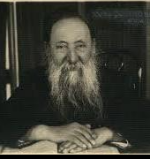
Rav Chaim Ozer Grodzinski

The Genius Among Geniuses
Legendary head of the Vilna Beis Din, R’ Chaim Ozer was the genius among geniuses, a man whose breadth and depth of knowledge seemed limitless, whose comprehension was characterized as indescribable, who possessed the ability to pursue three or four unrelated trains of thoughts simultaneously, without losing track or confusing any of them. He could be seen writing with both hands at the same time; or simultaneously writing a halachic response, computing charity amounts and discussing Torah with someone.
When he received the newly published first volume of Shaarei Yosher, a 320-page analytical work on Gemara by R’ Shimon Shkop, he began leafing through the sefer during breakfast and continued to do so for about an hour and a half after his meal. Then he closed the work and immediately proceeded to analyze various concepts scattered throughout its pages, obviously having digested all its contents

Constantly Working to Achieve a
Higher Level of Avodas Hashem.
But R’ Chaim Ozer did not rest on the laurels of his gift of genius. He channeled his abilities, and constantly worked to achieve yet a higher level of Avodas Hashem and yet more refined character traits - and therein lays his greatness.
His face glowed with wisdom and his eyes shone with goodness. To his modest apartment in Vilna streamed an endless flow of people in search of his wisdom, sympathy and assistance. His door was open day and night; no appointment was necessary. His living room would be filled at any given time with Rabbanim, Roshei Yeshiva, widows, orphans, Torah students and communal leaders.
R’ Chaim Ozer was born in 1863 in Ivye, a small town near Vilna, where his father, R’ Dovid Shlomo, was Rav for 40 years, preceded by his grandfather who had also served as Rav there for 40 years. R’ Dovid Shlomo taught his young son in his formative years. In spite of the chronic weakness from which R’ Chaim Ozer suffered from birth, he was an avid student. In addition to the vast amount of Torah he studied with his father, he constantly studied more on his own.
Impressed His Father with
His Psak on Kashrus

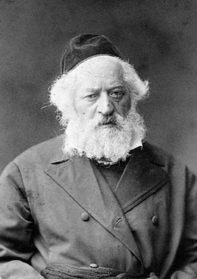
Rav Yitzchak Elchanan

When R’ Chaim Ozer was six years old, someone brought a kashrus shayloh to his father for a decision, which R’ Chaim Ozer proceeded to answer even before the person came into his father’s room. When his father later confirmed that his young son’s “psak” was correct, he asked him how he had known. R’ Chaim Ozer said that he had based it on what he had learned with his father that morning. His father drew him close and kissed him on the head.

At age 9, R’ Chaim Ozer delivered a stunning pilpul shiur for the scholars of the Beis Medrash in the town of Trab. R’ Yisrael Salanter had the opportunity then to test the young genius by citing a difficult problem posed in the Mishneh Lamelech, and offering his own solution to that problem based on a passage from the Yerushalmi in Kiddushin.
Young R’ Chaim Ozer rejected R’ Yisrael’s proof, citing the words of the Rosh on Masechta Shavuos as proof. R’ Yisrael was so impressed with the lad’s reasoning that he exclaimed, “For such a logical argument alone, you deserve a dowry of a thousand rubles!” By the age of ten, R’ Chaim Ozer was the talk of his hometown. To shield him from publicity, his father sent him to learn among the scholars of Aishishok.

Journeyed to Kovno to Speak in Learning eith Rav Yitzchak Elchanan Spector

During his first year in Aishishok, R’ Chaim Ozer and a friend journeyed to Kovno to “speak in learning” with R’ Yitzchak Elchanan Spector, Rav of Kovno and the foremost posek of that generation. They arrived in Kovno toward evening and spent the night in a local beis medrash. R’ Chaim Ozer’s friend was soon fast asleep, while he remained awake poring over a Masechta Yevamos. The strain of studying such a difficult masechta did not add to his fatigue; on the contrary, Torah study had the opposite effect on R’ Chaim Ozer, who remained studying throughout the night until he had reviewed the entire masechta by morning!
When R’ Chaim Ozer introduced himself to R’ Yitzchak Elchanan the next day, the latter asked what he was studying. R’ Chaim replied honestly that he had completed all of Yevamos the previous night. The incredulous Rav forged into a discussion of various topics scattered throughout the masechta; the discussion left R’ Yitzchak Elchanan in awe of this youth who would one day succeed him as one of Jewry’s greatest halachic authorities.

A Tendency for Chiddushim Related to Yevamos
In later years, someone remarked that R’ Chaim Ozer seemed to have a tendency toward chiddushim related to Yevamos. R’ Chaim Ozer nodded in agreement, and explained that his boyhood discussion with R’ Yitzchak Elchanan had left him with a particular clarity in the masechta.
Gifted with an infallible memory, R’ Chaim Ozer himself remarked that he never knew the meaning of “forgetting” until his old age. When asked to deliver the customary drasha at his Bar Mitzvah, he refused, saying he did not have time to prepare because he had spent all his time learning, and instead invited the guests to “Open any page in the Ketzos Hachoshen or in the Nesivos Hamishpat and I’ll recite it from memory.” They took up the
challenge and he responded – page after page, word for word, accompanied by a running commentary.

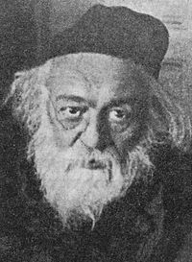
Rav Chaim Brisker

He also possessed a remarkably logical mind and lightning grasp. He enjoyed analyzing a subject in depth, and was not satisfied until he felt he had mastered it completely. He composed incisive chiddushim, and was soon a veritable wellspring of knowledge. His love of Torah was vibrant; he never tired of learning.
At age 15, R’ Chaim Ozer was learning together with R’ Sholom Ber Eisenstadt, Rav of Lechovitz – author of Kanfey Shachar and one of the most renowned Torah scholars of his day. The Rav found immense pleasure in sparring with the young prodigy and predicted a glowing future for him.
At this point, R’ Chaim Ozer decided to go learn in the Volozhiner Yeshiva, where, in spite of his tender age, he was immediately accepted into R’ Chaim Brisker’s select group. A powerful bond was forged between the two in those years, which endured for the rest of their lives. In the course of time, R’ Chaim Brisker came to view R’ Chaim Ozer as a younger colleague, as the two eventually worked hand-in-hand in matters affecting Klal Yisrael.
The yahrzeit of R’ Chaim Ozer ben R’ Dovid Shlomo Grodzenski zt”l is on 5 Av (1940). May his merit protect us. (The Torah Personality, Torah Lives, Reb Chaim Ozer, Giants of Jewry)

Reprinted from the Parshas Matos-Masei 5781 email of The Weekly Vort.

Three Seemingly Unrelated
Examples of the Hand of Hashem

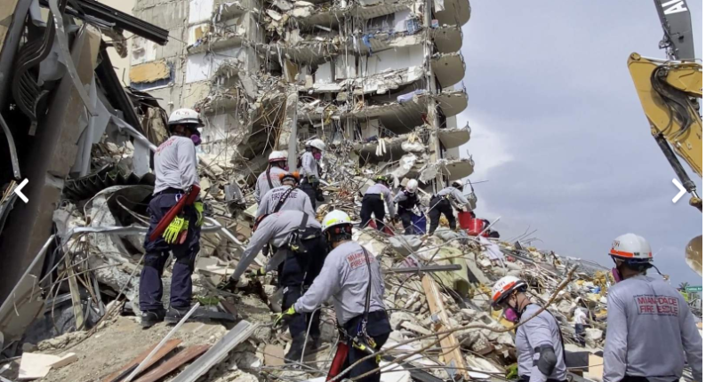

The following three seemingly unrelated instances tie together to show the Hand of Hashem. A woman, exhausted from her newborn’s cries, called her mother to come stay with her to help with the infant. Her mother packed her bags and rushed to stay with her daughter to give her a good night’s sleep.
Another woman was sweltering in her apartment building, because her air conditioning broke. She decided to go stay with her family overnight, hoping it would get fixed in the morning.
A family was vacationing away from their home. They went on a trip to Orlando and were scheduled to arrive back to their apartment Thursday, June 24th. Their young son was having a great time on vacation and begged his parents to stay one more night.
Three completely unrelated stories with a common thread. The two women and the family all were residents of the Champlain Towers South in Surfside, Florida. These are incredible miracles from Hashem!! They were out the exact night the building collapsed. May we hear many many more miracles like this soon B’H.

Reprinted from the Parshat Mattos-Masei 5781 email of Jack E. Rahmey as based on the Torah teachings of Rabbi Amram Sananes.
The Courageous Rebuke
Of the Rosh Hayeshiva

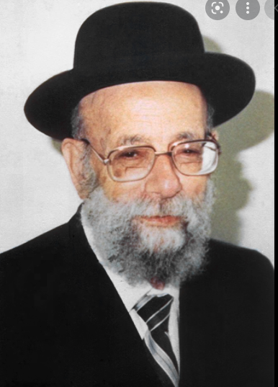

An amazing story took place with Rav Yehuda Tzadkah, zt”l. He did not hesitate to give Mussar to those who needed it because of Aveiros they may be doing, even if they were wealthy people. However, he always did this in a pleasant way and with sweetness, and this only helped to bring them closer to the Torah and to Yiddishkeit.
The Yeshivah Porat Yosef, where Rav Yehuda Tzadkah was the Rosh Yeshivah, was having a very difficult time financially. The small income from the generous donations in Eretz Yisroel was not enough for to cover even the minimum of their expenses. Without any choice, the Yeshiva administrators approached Rav Tzadkah, and they told him of the desperate situation the Yeshivah was in. They felt that they were left with only one option, and that was for the Rosh Yeshivah himself to embark on the long journey to the faraway lands of America, and try to speak to the hearts of the wealthy American Jews, and to persuade them to donate generously to the Yeshivah.
Rav Tzadkah was not at all interested in leaving Eretz Yisroel, and he tried to think of every possible alternative, but he realized that if the Yeshivah were to continue to exist, he would have to go on the journey to America. After a long and arduous trip, Rav Tzedakah arrived in America. The Jews of the place welcomed him with great respect and honor, and asked him to speak in Shul that Shabbos.
It should be noted that in that time period, the condition of the Ruchniyus of the American Jews was very lacking. Most Jews were irreverent to those who lived a Torah life. They degraded the observance of the Mitzvos, and dismissed doing them. However, it was precisely because of this that their conscience tormented them over their many Aveiros, and the hearts of these Jews were warm and open to being generous when giving Tzedakah, and doing Chesed.

Viewing a Most Horrifying Spectacle of
Jews Coming to Shul in Their Cars!
When Shabbos arrived and Rav Tzadkah came to Shul, a horrifying spectacle happened before him. Upright Jews came to Shul on Shabbos in their cars! They parked in the Shul courtyard, and walked into Shul without even a thought that they were Mechalel Shabbos!
Rav Tzadkah was very sad to see this, and he now faced a difficult dilemma. If he would speak to them about how much financial trouble his Yeshivah was in, they would surely listen to him and donate generously. However, this may also cause them to think in their hearts that by donating, they are compensating for their many Aveiros, and they will continue to go in their terrible ways.
When it came time for him to speak, the Rav smiled and began by saying, “I heard about you that you are Tzadikim and that you do much Chesed and give much Tzedakah. These great Mitzvos will surely stand in your merit in Olam Haba. How great is your reward!”

Declares He Has No Interest in Their Donation
After Rav Tzadkah made them happy by praising them, they were now more inclined to listen to him, and he began to softly rebuke them over their Aveiros, and that they actually stood to lose all of their many merits because they are not careful to keep the Mitzvos. Finally, Rav Tzadkah finished and said, “If there are those among you who think that because you give a donation, it is permitted to continue to stumble and do Aveiros, I am, letting you know in advance that I am a not interested in your donation.”
The Gabai of the Shul, was astonished at the scathing rebuke, and he whisper to the Rav, “Never has anyone dared to speak in such a way to the members of our rich community. Now, certainly no one will contribute anything to the Rav!”
But an amazing thing happened. The moment after Rav Tzadkah’s speech ended, the rich people began to compete among themselves as to who would donate more money for the Yeshivah, and to start correcting their ways. And on that Motza’ei Shabbos, they collected a huge fortune, three times the amount that the Yeshivah needed to raise!
Reprinted from the Parshas Devorim 5781 edition of Rabbi Yehuda Winzelberg’s Torah U Tefilah email.
Calling Out for Levi Stein
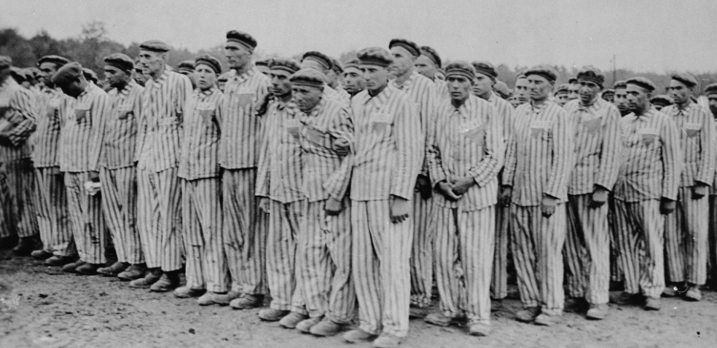
Rav Meilech Biderman once related that during the Holocaust, in one of the concentration camps, there was a Nazi Rasha, and every night he would randomly call out a name as the people would line up for roll call, and he would afflict that person with terrible suffering.
One day during roll call, the Rasha called out, “Levi Stein! Come Forward!” We can’t judge Levi Stein for what he did, as we can’t judge anybody who went through the Holocaust.
He turned to the person standing next to him in line and said, “Nu! Levi! Why aren’t you going forward? The guard called your name!
That person was Rav Avraham Steiner, zt”l, who later lived in Bnei Brak. He quickly assessed the situation. He could have claimed that his name wasn’t Levi Stein, but he decided that this turn of events was from Shamayim, and he didn’t want to do anything that would hurt another person. He stepped forward, and was ready to accept any pain or torture, so that Levi wouldn’t have to suffer. The Nazi criminal said, “This time, we are going to play a different game. This time, the person who came forward will live, and everyone else will die!” And so it was. Rav Steiner’s life was saved, just by being a caring, selfless Yid, because he didn’t want another Yid to suffer.

Reprinted from the Parshas Devorim 5781 edition of Rabbi Yehuda Winzelberg’s Torah U Tefilah email.

